Project Report: Building a Badminton AI on a Legacy System
Project Phase: MVP 1.0 (Minimum Viable Product)

1. Project Overview
The goal of this project is to repurpose an old Intel i7 computer to create an AI-powered sports analysis tool. By leveraging Computer Science and Mathematics, this system tracks human joints in real time to analyze the efficiency of a badminton smash.
2. System Installation & Environment Setup
To ensure maximum performance for AI calculations, I migrated the operating system from Windows to Linux.
2.1 OS Installation Process
- Operating System: Ubuntu 22.04 LTS (Linux).
- Installation Method: Created a bootable USB drive using Rufus.
- Configuration: Configured BIOS to boot from USB and performed a clean install to optimize CPU resources.
2.2 Troubleshooting (Problem-Solving)
- Challenge1: During the USB creation, Rufus encountered a "Download Incompatible" error regarding bootloader files (ldlinux.sys).
- Solution1: Manually adjusted the partition scheme (GPT vs. MBR) and verified the ISO integrity, successfully bypassing the network restriction.
- Challenge2: The system fails to locate the bootloader when attempting to boot from the USB installation media
Search website get the possible reason is ：
BIOS/UEFI Mode: Your old computer might only support Legacy (MBR) mode, while your bootable USB drive was likely created in UEFI (GPT) mode.
Secure Boot: Some older computers require you to disable Secure Boot to allow booting from a non-Windows USB drive.

Solve the problem steps:
To fix the boot issue, try re-flashing the USB drive in Rufus with these specific settings:
- Target System: Switch to "BIOS (or UEFI-CSM)".
- Partition Scheme: Choose "MBR" instead of GPT.

- Solution2: Manually adjusted the partition scheme (GPT vs. MBR) and verified the ISO integrity, successfully bypassing the network restriction.
Final solution:
Need to set USB3.0 Configuration in Pre-OS to Auto
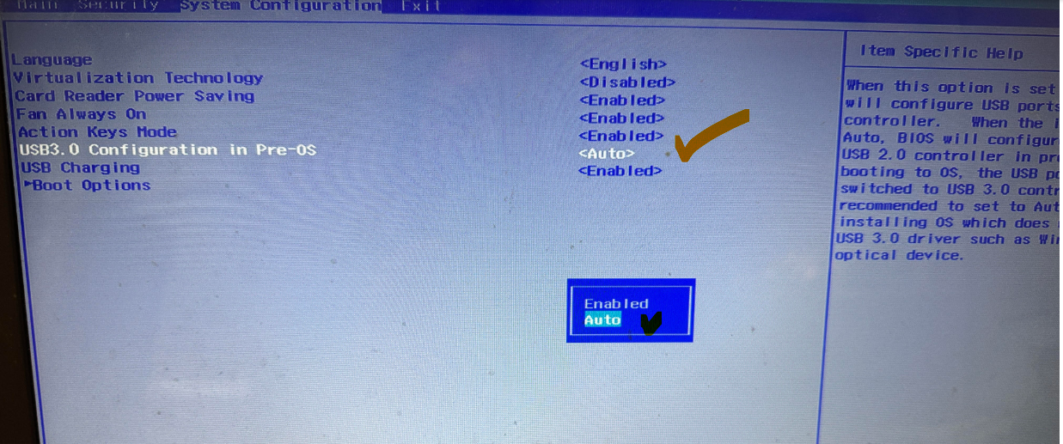

3. Technical Implementation
The project is built using Python and professional-grade AI libraries.
3.1 Software Stack
- Python 3.10: The core programming language.
- OpenCV: For real-time video stream processing.
- Mediapipe: A framework by Google for high-fidelity body pose estimation.
- Numpy: For high-speed mathematical vector calculations.
3.2 The Mathematics (Logic)
To analyze the smash, I implemented the Arc Tangent (atan2) function to calculate the angle between three 3D coordinates: the Shoulder, Elbow, and Wrist.
Formula Logic: Angle = |(Angle2 - Angle1) * 180 / PI|
4. MVP 1 Results
The system successfully achieves the following:
- Real-time Tracking: Detects 33 body landmarks at 30+ FPS.
- Visual Feedback: Overlays a "Skeleton" on the video feed.
- Data Output: Displays the live "Smash Angle" in degrees on the screen.
5. Reflection & Learning Outcomes
- Math Application: I learned how school geometry (Trigonometry) is used in real-world AI.
- Engineering Skills: I mastered Linux terminal commands and Python virtual environments (venv).
- Next Steps: My next goal is to implement data logging to record the maximum angle reached during a jump smash.

